Bean Init and Destroy Methods

Create a project named 07_ BeanInitAndDestroyMethods and copy the previous project files at our new project and we will work from there.

1. Add onCreate() Method on Patient.java class

|  |
| --- |
| **public** **void** **onCreate**() {  **System**.***out***.println("Patient Created!");  } |

1. Go to patient bean at beans.xml
2. initMethod=onCreate

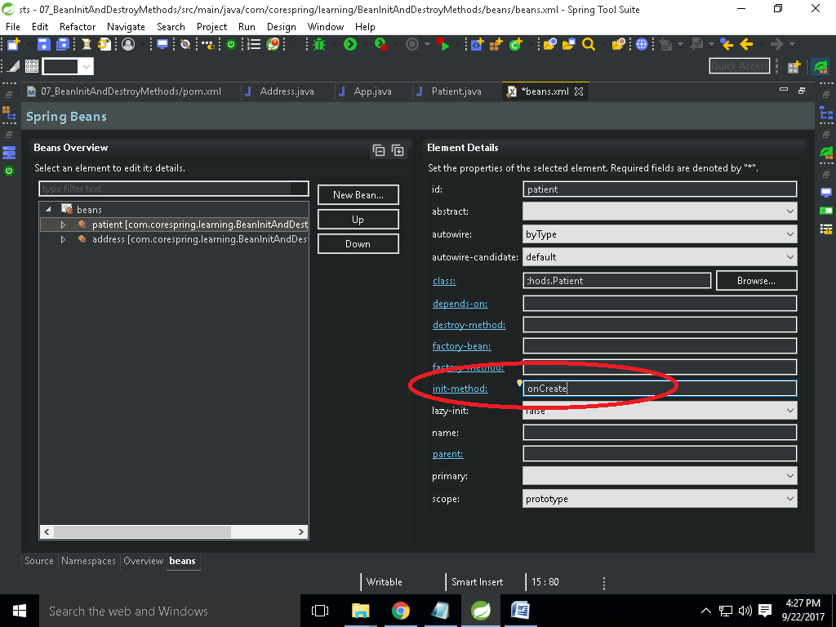

1. Save and run App.java
2. onCreate method is working
3. Now create onDestroy method
4. Go to patient bean at beans.xml
5. Destroy-Method=onDestroy
6. If we run we see that onDestroy is not working because we are using patient bean scope as prototype. Because prototype means everything will handle by user code. So destroy method is not calling.
7. Now we need to change the patient bean scope as singleton
8. Run the App.java
9. onDestroy method is working
10. We can set init and destroy method globally at out beans.xml
    1. Go to beans.xml
    2. Select beans
    3. Default-init-method=init
    4. Defauld-destroy-method=destroy
11. Go to Address class
12. Add init and destroy method
13. Run App.java
14. That is working